How to create an appeal page
This is a short step-by-step guide on how to create an appeal page for your group.
If you need any further assistance then please feel free to call our helpline on 0300 111 2340. The line is open between 9.30am – 5.30pm Monday – Friday. You can also find more information about appeal pages by clicking here and looking at the help section of our website.

- Log-in to your Localgiving account and click on the My Pages section
- Then click on the right hand, green, Create an appeal page button
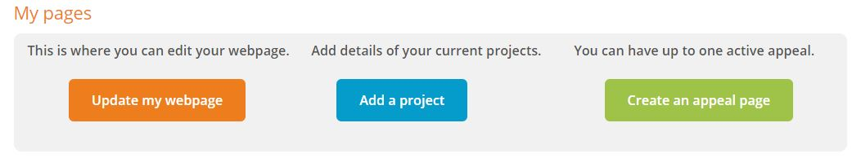
- Be aware that you can only have 3 draft appeals and one active appeal at any one time. If the button is greyed out then please delete a draft appeal first.
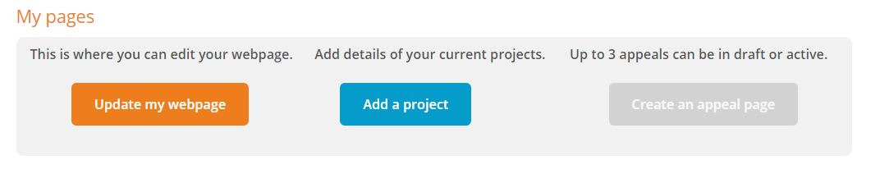
- Once you have clicked on Create an appeal you will be asked to enter the name of the Appeal as well as the unique URL which you can share with your supporters.

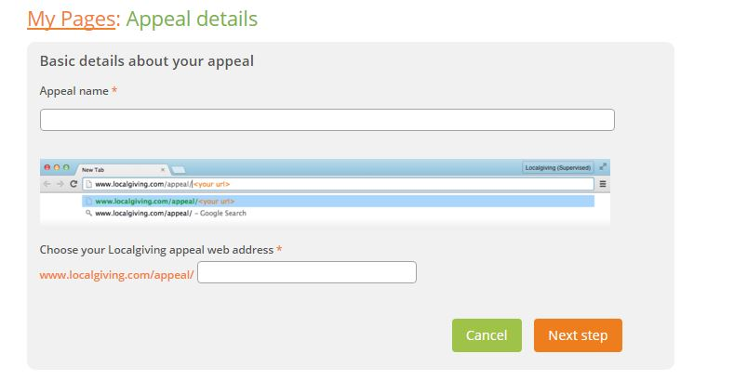
- After you’ve clicked on Next Step you will find the main edit page. This is where you can enter all the details of your appeal. The key features to be aware of are:
- Dates – Your appeal page will go offline once it reaches its End Date so if your appeal isn’t appearing on your page please check these dates
- Funds raised – here is where you can enter any funds you raised offline. Please be aware that these will be added to your fundraising toolbar
- Offline/Online toggle – you need make sure the toggle is moved to online before clicking Submit otherwise it will not appear on your main charity page. If you keep it offline when clicking Submit the appeal will appear in your draft appeal section (see 6)
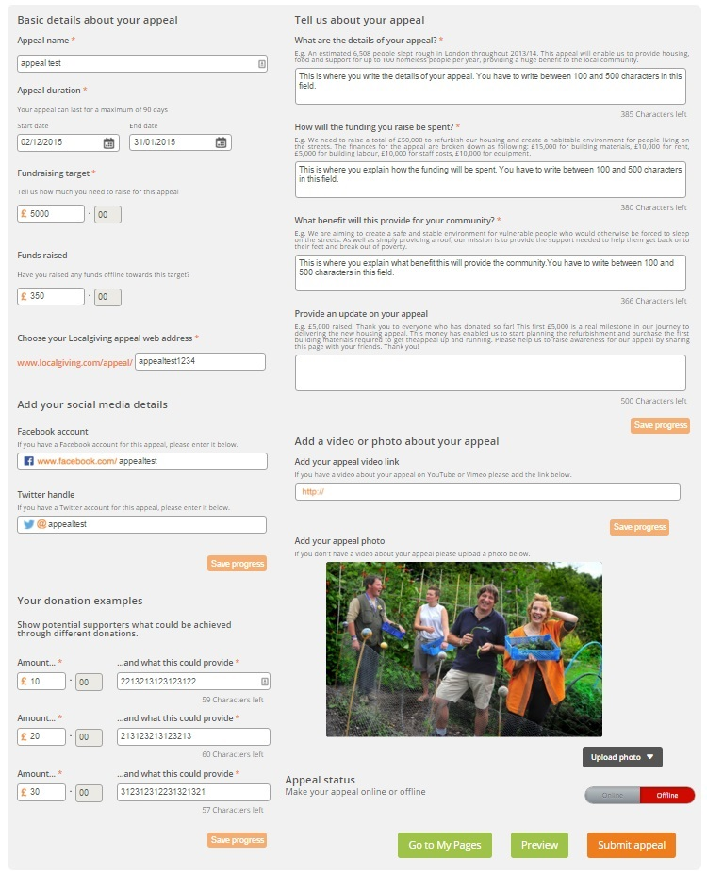

- If you keep you new appeal offline it will appear in the My draft appeals section. The My offline appeals section is for old appeals that are past their End date and so now offline.
- Remember you can have one active appeal and three draft appeals at any one time
- You can also use the button underneath Edit to make an offline appeal online again or vice versa, although you may need to edit the End date first.
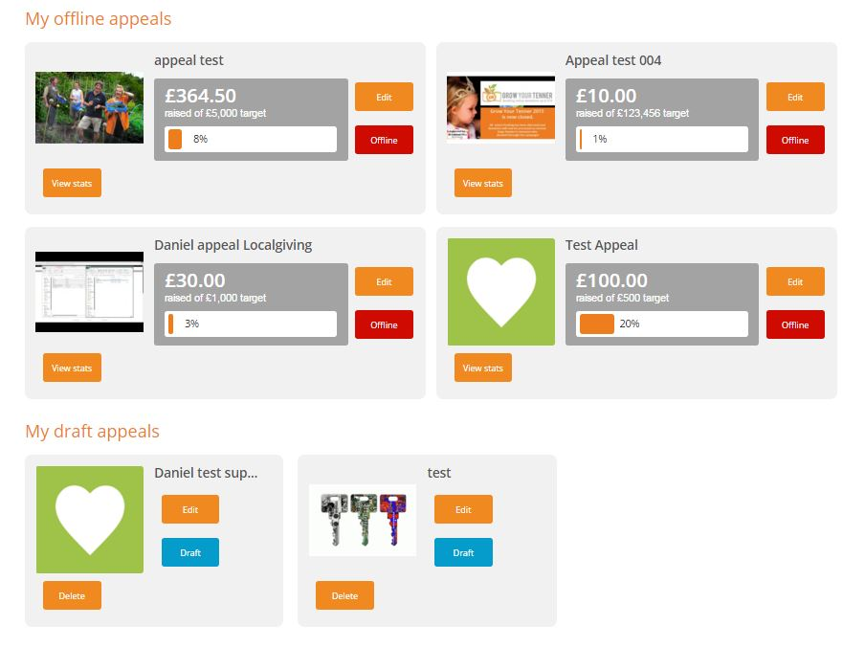
- You can have as many offline appeals as you like, these are historic appeals that include a View Stats button so you can see how well they did.

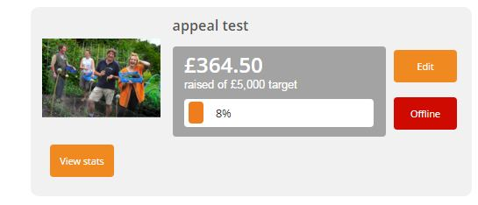

- Once you make your appeal online and it goes live it will appear at the top of your My Pages screen
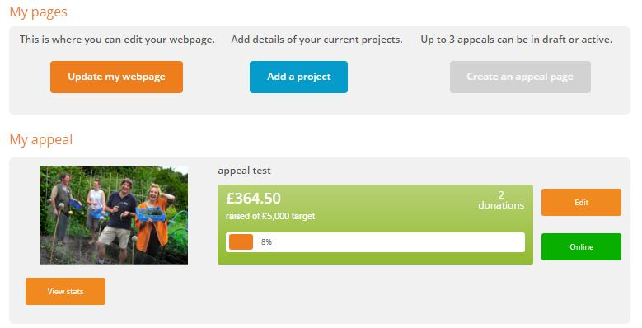
- You will also see a new tab at the top right hand corner of your charity page

